Real Estate Leasing Firm Database

## Abstract

This database is designed to store information relating to the operation of the business management of a real estate leasing firm. It stores information about the branches of the business, departments of the business, staff members, prospective tenants, sitting tenants, property owners, and statuses. The database supports the operation of Real Estate leasing business records on rent paid by the tenants, rent remitted to the property owners, status of properties, and property listings.

## Mission Statement

The purpose of the Real Estate Firm Database system is to maintain the data that is used and generated to support the real estate leasing management business for our clients and property owners and to facilitate the cooperation and sharing of information between staff, departments, and branches.

## Mission Objectives

1. To maintain (enter, update, and delete) data on tenants.
2. To maintain (enter, update, and delete) data on staff members.
3. To maintain (enter, update, and delete) data on properties.
4. To maintain (enter, update, and delete) data on departments.
5. To maintain (enter, update, and delete) data on owners.
6. To maintain (enter, update, and delete) real estate firm branches.
7. To maintain (enter, update, and delete) statuses.
8. To perform searches on tenants.
9. To perform searches on staff members.
10. To perform searches on departments.
11. To perform searches on real estate firm branches.
12. To perform searches on properties.
13. To perform searches on owners.
14. To perform searches on statuses.
15. To track the status of properties.
16. To report the status of properties to owners.
17. To report the status of properties to tenants.
18. To report transactions between staff members and tenants to owners.

E/R Diagram

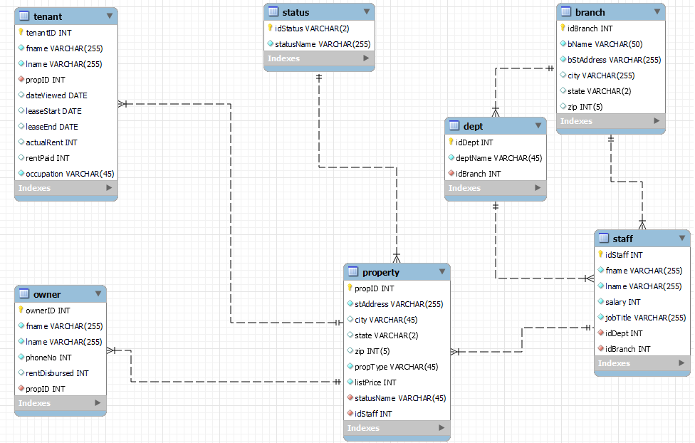

## Relational Model

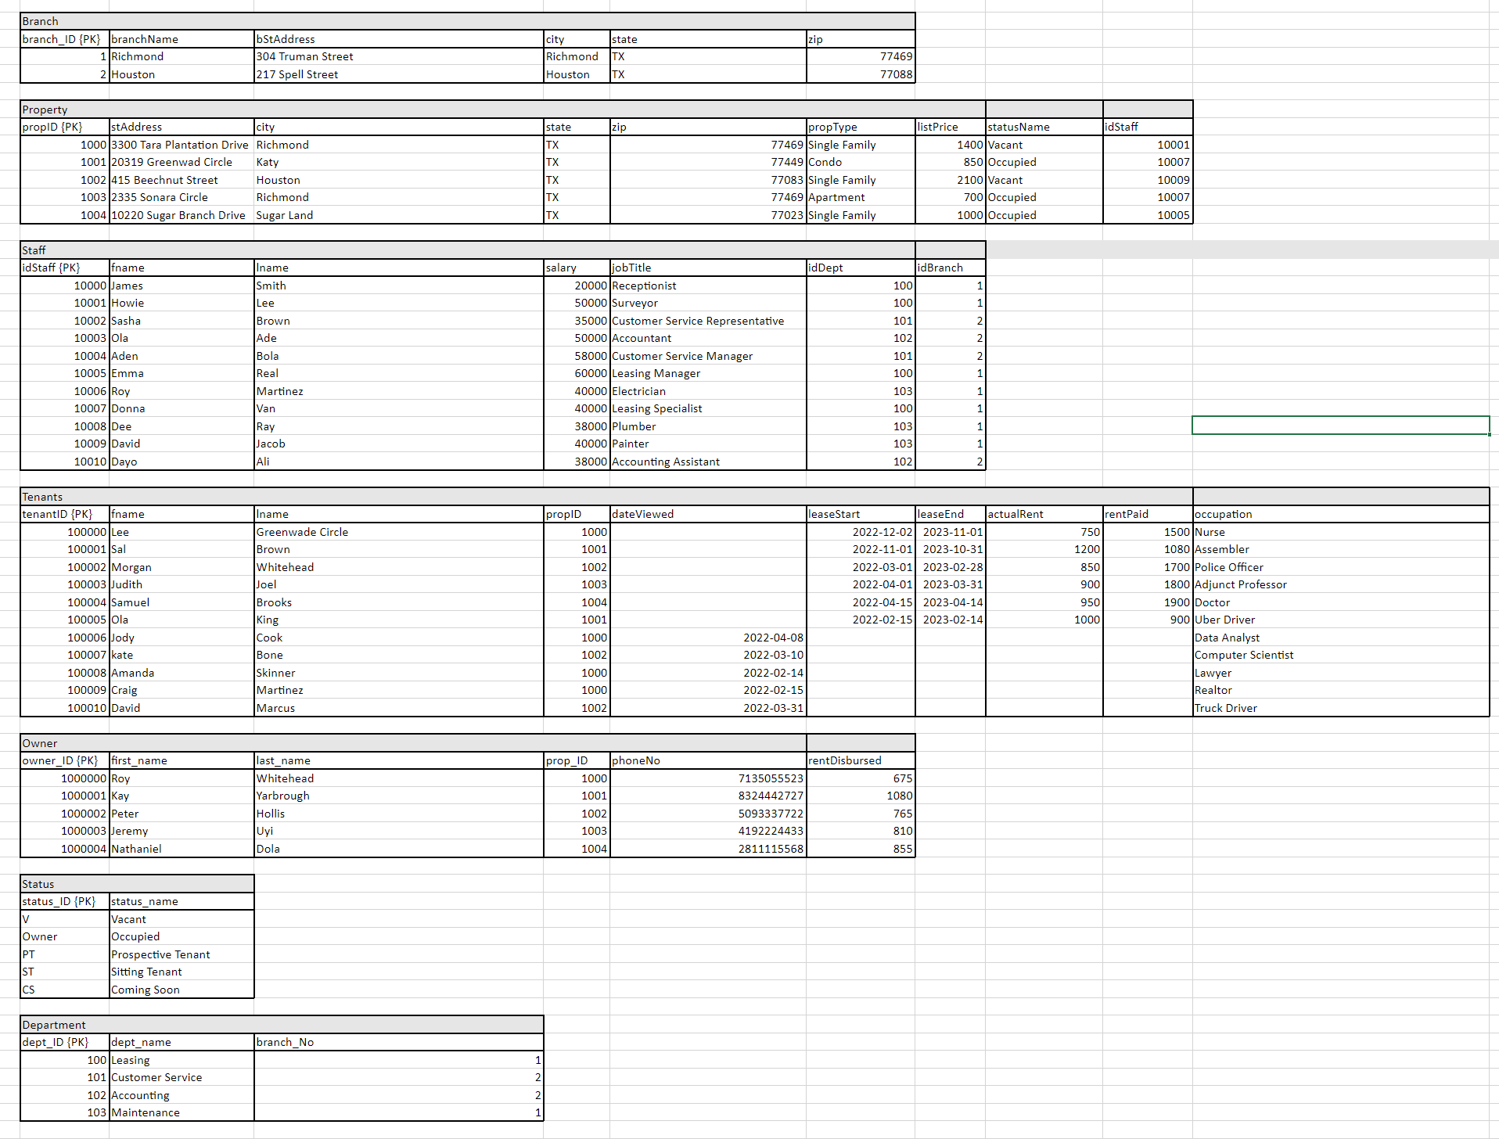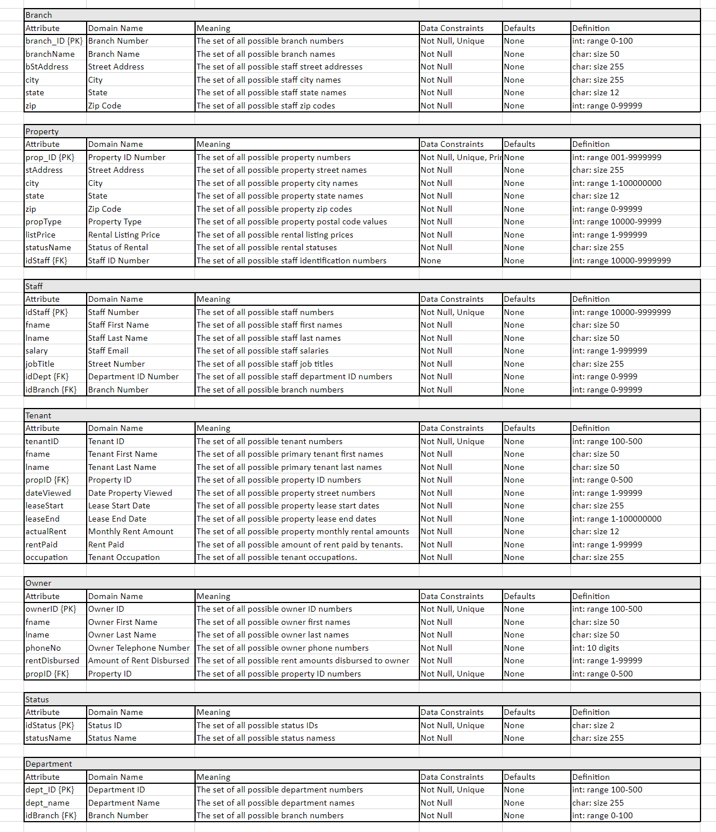

## Use Cases

Insertion

1. **Entering a new staff member**
   1. Actor: Manager
   2. Steps:
      1. User clicks “new” button; user selects staff
      2. A new staff ID is generated and displayed
      3. Prompts user to enter first name, last name, job title, salary, branch information, DOB, email, address, department information, and phone number
      4. All information is displayed; ask for confirmation
      5. User clicks “Confirm” button to save the new employee
   3. SQL statement:
      1. INSERT INTO Staff VALUES (staff_ID, name, email, staff_address, phone_no, salary, dept_ID, DOB, job_title, branch_ID)
   4. Use case realization:
      1. This will allow a manager to enter a staff member and their contact information when they have a new hire.
2. **Entering a new tenant**
   1. Actor: Staff
   2. Steps:
      1. User clicks “new” button; user selects tenant
      2. A new tenant ID is generated and displayed
      3. Prompts user to enter first name, last name, property information, tenant current address, other occupant information, email, status, and phone number
      4. All information is displayed; ask for confirmation
      5. User clicks “Confirm” button to save the new tenant
   3. SQL statement:
      1. INSERT INTO Tenant VALUES (tenant_ID, primary_name, prop_ID, prop_address, phone_no, email, tenant_address, other_occupant, status)
   4. Use case realization:
      1. This will allow the user to input a new tenant and their information so that they can reference the tenant if they call again.
3. **Entering a new property**
   1. Actor: Staff, Supervisor
   2. Steps:
      1. User clicks “New”; user selects property..
      2. A new property ID is generated and displayed.
      3. Prompts user to search for/select a property and enter property address, property description, owner ID, tenant ID, list price, MLS number, property type, property availability date.
      4. All information is displayed and asks for confirmation.
      5. User clicks “confirm” button to save the new property.
   3. SQL statement:
      1. INSERT INTO Property VALUES (prop_ID, prop_address , owner_ID, tenant_ID, list_price, mls_No, prop_type, status_name)
   4. Use case realization:
      1. This will allow the user to input a new property that needs to be listed for rent.
4. **Entering a new owner**
   1. Actor: Staff, Supervisor
   2. Steps:
      1. User clicks “new” button; user selects owner
      2. A new owner ID is generated and displayed
      3. Prompts user to enter the owner name, property address, property ID, email, phone number, and property type.
      4. All information is displayed and asks for confirmation
      5. User clicks on “Confirm Button” to save the new owner
   3. SQL statement:
      1. INSERT INTO Owner VALUES (owner_ID, name, prop_ID, prop_address, email, phone_no, prop_type)
   4. Use case realization:
      1. Allows the user to enter a new owner for a new property.
5. **Entering a new real estate firm branch**
   1. Actor: Director
   2. Steps:
      1. User clicks “new” button; user selects branch
      2. A new branch ID is generated and displayed
      3. Prompts user to enter or select a branch ID, branch name, and branch address)
      4. All information is displayed and asks for confirmation
      5. User clicks on “Confirm Button” to save the new branch
   3. SQL statement:
      1. INSERT INTO Branch VALUES (branch_ID, branch_name, branch_address)
   4. Use case realization:
      1. Allows the director to enter a new branch when an additional new real estate leasing firm is opened.
6. **Entering a new department**
   1. Actor: Director
   2. Steps:
      1. User clicks “new” button; user selects department
      2. A new department ID is generated and displayed
      3. Prompts user to enter the department name and branch number.
      4. All information is displayed and asks for confirmation
      5. User clicks on “Confirm Button” to save the new call center
   3. SQL statement:
      1. INSERT INTO Department VALUES (dept_ID, dept_name, branch_ID)
   4. Use case realization:
      1. Allows the director to enter a new department when one is created.
7. **Entering a new status**
   1. Actor: Director, Manager
   2. Steps:
      1. User clicks “new” button; user selects status
      2. A new status ID is generated and displayed
      3. Prompts user to enter the status name.
      4. All information is displayed and asks for confirmation
      5. User clicks on “Confirm Button” to save the new status.
   3. SQL statement:
      1. INSERT INTO Department VALUES (dept_ID, dept_name, branch_ID)
   4. Use case realization:
      1. Allows the director to enter a new department when one is created.

Removal

1. **Deleting a staff**
   1. Actor: Manager, Supervisor (Head of Department)
   2. Steps:
      1. User clicks “remove” button; user selects staff_ID
      2. Prompts user to select Real Estate staff_ID
      3. All information is displayed and asks for confirmation
      4. User clicks on “Delete Entry Button”
   3. SQL statement:
      1. DELETE FROM Staff WHERE staff_ID = ‘staff_ID’
   4. Use case realization:
      1. Allows user to remove a staff upon termination of employment
2. **Deleting a Tenant**
   1. Actor: Manager, Supervisor (Head of Department)
   2. Steps:
      1. User clicks “remove” button; user selects tenant
      2. Prompts user to select a tenant
      3. All information is displayed and asks for confirmation
      4. User clicks on “Delete Entry Button”
   3. SQL statement:
      1. DELETE FROM Tenant WHERE tenant_ID = ‘tenant_ID’
   4. Use case realization:
      1. Allows user to remove a tenant, in the event that the tenant is no longer reside in any of the company properties.
3. **Deleting a property**
   1. Actor: Manager
   2. Steps:
      1. User clicks “remove” button; user selects property
      2. Prompts user to select a Real Estate Property
      3. All information is displayed and asks for confirmation
      4. User clicks on “Delete Entry Button”
   3. SQL statement:
      1. DELETE FROM Property WHERE prop_ID = ‘prop_ID’
   4. Use case realization:
      1. Allows the user to remove a property in the event the owner withdrawn the instruction to manage such property.
4. **Deleting an Owner**
   1. Actor: Manager
   2. Steps:
      1. User clicks “remove” button; user selects Owner
      2. Prompts user to select Real Estate property owner.
      3. All information is displayed and asks for confirmation
      4. User clicks on “Delete Entry Button”
   3. SQL statement:
      1. DELETE FROM Owner WHERE owner_ID = ‘owner_ID’
   4. Use case realization:
      1. Allows user to remove an owner in the event that the real estate property owner is longer with the Real Estate Organization.
5. **Deleting a Department**
   1. Actor: Manager
   2. Steps:
      1. User clicks “remove” button; user selects Department
      2. Prompts user to select department
      3. All information is displayed and asks for confirmation
      4. User clicks on “Delete Entry Button”
   3. SQL statement:
      1. DELETE FROM Department WHERE dept_ID = ‘dept_ID’
   4. Use case realization:
      1. Allows the user to delete a department if a department closure occurs
   5. **6. Deleting a branch**
   6. Actor: Director
   7. Steps:
      1. User clicks “remove” button; user selects branch
      2. Prompts user to select a branch
      3. All information is displayed and asks for confirmation
      4. User clicks on “Delete Entry Button”
   8. SQL statement:
      1. DELETE FROM Branch WHERE branch_ID = ‘branch_ID’
   9. Use case realization:
      1. Allows the user to remove a branch in the event of a branch closure
6. **Deleting a new status**
   1. Actor: Director, Manager
   2. Steps:
      1. User clicks “remove” button; user selects status
      2. Prompts user to select a status.
      3. All information is displayed and asks for confirmation
      4. User clicks on “Delete Entry Button”.
   3. SQL statement:
      1. DELETE FROM Status VALUES (status_ID, status_name)
   4. Use case realization:
      1. Allows the director or manager to remove status as needed.

Management

1. **Updating a Staff**
   * + - 1. Actor: Manager, Supervisor (Head of Department)
         2. Steps:
2. User clicks “update” button
3. Prompts user to select a which entity to update
4. User selects staff and is prompted to select a department and Branch
5. Prompts user to update staff information
6. All information is displayed and asks for confirmation
7. User clicks on “Confirm Button”
   * + - 1. SQL statement:
     1. UPDATE Staff SET ‘column’ = ‘new column value’ WHERE staff_ID = ‘some_Staff_ID”
8. Use case realization:
   * 1. Allows the user to update the contact information for a staff when necessary.
9. **Updating a property**
10. Actor: Manager, Supervisor, Staff
11. Steps:
12. User clicks “update” button
13. Prompts user to select a which entity to update
14. User selects property is prompted to update the property information
15. Prompts user to update property information
16. All information is displayed and asks for confirmation
17. User clicks on “Confirm Button”
    1. SQL statement:
       1. UPDATE Property SET ‘column’ = ‘new column value’  WHERE prop_ID = ‘some_prop_ID”
    2. Use case realization:
       1. Allows the user to update the property information when necessary
18. **Updating a Tenant**
    1. Actor: Supervisor, Staff
    2. Steps:
       1. User clicks “update” button
       2. Prompts user to select a which entity to update
       3. User selects Tenant is prompted to update the tenant information
       4. Prompts user to update Tenant information
       5. All information is displayed and asks for confirmation
       6. User clicks on “Confirm Button”
    3. SQL statement:
       1. UPDATE Tenant SET ‘column’ = ‘new column value’ WHERE tenant_ID = ‘some_tenant_ID’
    4. Use case realization:
       1. Allows the user to update the information on a tenant
19. **Updating an Owner**
    1. Actor: Manager, Supervisor
    2. Steps:
       1. User clicks “update” button”
       2. Prompts user to select a which entity to update
       3. User selects owner and is prompted to update the property owner’s information
       4. All information is displayed and asks for confirmation
       5. User clicks on “Confirm Button”
    3. SQL statement:
       1. UPDATE Owner SET ‘column’ = ‘new column value’ WHERE owner_ID = ‘some_owner_ID’
    4. Use case realization:
       1. Allows user to update an owner if the owner decide to be with the organization
20. **Updating a department**
    1. Actor: Manager
    2. Steps:
       1. User clicks “update” button
       2. Prompts user to select a which entity to update
       3. User selects department and is prompted to update the department information
       4. All information is displayed and asks for confirmation
       5. User clicks on “Confirm Button”
    3. SQL statement:
       1. UPDATE Depart SET ‘column’ = ‘new column value’ WHERE dept_ID = some_ ‘dept_ID’
    4. Use case realization:
       1. Allows the user to update a department if there are information errors or updates
21. **Updating a branch**
    1. Actor: Director
    2. Steps:
       1. User clicks “update” button
       2. Prompts user to select a which entity to update
       3. User selects branch and is prompted to update the real estate information
       4. All information is displayed and asks for confirmation
       5. User clicks on “Confirm Button”
    3. SQL statement:
       1. UPDATE Branch SET ‘column’ = ‘new column value’  WHERE branch_ID = ‘some_branch_ID’
    4. Use case realization:
       1. Allows the user to update branch information in the event of address changes, etc.
22. **Updating a status**
    1. Actor: Director, Manager
    2. Steps:
       1. User clicks “update” button
       2. Prompts user to select which entity to update
       3. User selects status and is prompted to update the status name
       4. All information is displayed and asks for confirmation
       5. User clicks on “Confirm Button”.
    3. SQL statement:
       1. UPDATE Status SET ‘column’ = ‘new_column_value’ WHERE status_name = ‘some_status_name’
    4. Use case realization:
       1. Allows the user to update status information when the name of a status changes.

Relationships

1. **Assigning a staff member to a branch**
   1. Actor: Manager
   2. Steps:
      1. User clicks “assign” button
      2. Prompts user to select which staff member and branch
      3. All information is displayed and asks for confirmation
      4. User clicks on “Confirm Button”
   3. SQL statement:
      1. UPDATE Branch SET branch_ID = ‘new branch_ID value’ WHERE staff_ID = ‘staff_ID’
   4. Use case realization:
      1. Allows the user to assign a staff member to a specific branch.
2. **Assigning a property to an owner**
   1. Actor: Staff
   2. Steps:
      1. User clicks “assign” button
      2. Prompts user to select an owner and the property
      3. All information is displayed and asks for confirmation
      4. User clicks on “Confirm Button”
   3. SQL statement:
      1. UPDATE Property SET owner_ID = ‘new owner_ID value’ WHERE prop_ID = ‘prop_ID’
   4. Use case realization:
      1. Allows the user to assign a new owner to a property
3. **Assigning a department to a branch**
   1. Actor: Director
   2. Steps:
      1. User clicks “assign” button
      2. Prompts user to select a branch and the department
      3. All information is displayed and asks for confirmation
      4. User clicks on “Confirm Button”
   3. SQL statement:
      1. UPDATE Department SET branch_ID = ‘new branch_ID value’ WHERE dept_ID = ‘dept_ID’
   4. Use case realization:
      1. Allows the user to assign a department to a branch if a new branch is opened or a new department is created.
4. **Assigning a property to a tenant**
   1. Actor: Staff
   2. Steps:
      1. User clicks “assign” button
      2. Prompts user to select a tenant and the property
      3. All information is displayed and asks for confirmation
      4. User clicks on “Confirm Button”
   3. SQL statement:
      1. UPDATE Property SET tenant_ID = ‘new tenant_ID value’ WHERE prop_ID = ‘prop_ID’
   4. Use case realization:
      1. Allows the user to assign a new tenant to a property
5. **Assigning a staff member to a department**
   1. Actor: Manager, Supervisor
   2. Steps:
      1. User clicks “assign” button
      2. Prompts user to select which staff member and department
      3. All information is displayed and asks for confirmation
      4. User clicks on “Confirm Button”
   3. SQL statement:
      1. UPDATE Branch SET dept_ID = ‘new dept_ID value’ WHERE staff_ID = ‘staff_ID’
   4. Use case realization:
      1. Allows the user to assign a staff member to a specific department.
6. **Assigning a staff member to an owner**
   1. Actor: Supervisor, Manager
   2. Steps:
      1. User clicks “assign” button
      2. Prompts user to select which staff member to assign; then which owner they are being assigned to
      3. User selects staff member and owner
      4. Information is displayed and asks for confirmation to assign the staff member to the owner.
      5. User clicks on “Confirm Button”
   3. SQL statement:
      1. UPDATE Owner SET owner_ID = ‘old_owner_ID_value’ + “, ” + ‘new_owner_ID_value’ WHERE staff_ID = ‘staff_ID’
   4. Use case realization:
      1. Assigns a staff member to a property owner.
7. **Assigning a staff member to a tenant**
   1. Actor: Supervisor, Manager
   2. Steps:
      1. User clicks “assign” button
      2. Prompts user to select which staff member to assign; then which tenant to assign them to.
      3. User selects staff member and tenant
      4. All information is displayed and asks for confirmation to assign the staff member to the tenant.
      5. User clicks on “Confirm Button”
   3. SQL statement:
      1. UPDATE Tenant SET tenant_ID = ‘old_tenant_ID_value’ + “, ” + ‘new_tenant_ID_value’ WHERE staff_ID = ‘staff_ID’
   4. Use case realization:
      1. Assigns a staff member to a tenant.
8. **Query a tenant and their property (tenant -> property**
   1. Actor: Staff, Manager, Supervisor
   2. Steps:
      1. User clicks “Find” button
      2. Prompts user to select which entity to search by; user selects Property
      3. Prompts user select a property
      4. Tenant is displayed for the requested property
      5. User clicks on “Close Button” to exit
   3. SQL statement:
      1. SELECT property.propID, property.stAddress, property.city, property.state, property.zip, property.propType, tenant.fname, tenant.lname, tenant.tenantID, tenant.occupation, tenant.dateViewed, tenant.leaseStart, tenant.leaseEnd, property.listPrice, tenant.actualRent, tenant.rentPaid, property.statusName FROM tenant, property WHERE tenant.propID = property.propID AND property.propID = ‘property_ID_value’;
   4. Use case realization:
      1. Allows the user to search and locate a tenant and the property that they are renting if they are a current tenant which allows the user to see any properties currently rented by this tenant.
9. **Query all departments for a branch (branch-> staff -> properties)**
   1. Actor: Manager
   2. Steps:
      1. User clicks a button to view all branches
      2. Prompts user to select a branch
      3. Displays all departments for that branch
   3. SQL statement:
      1. SELECT dept.idDept, dept.deptName, branch.* FROM Dept, Branch WHERE branch.idBranch = dept.idBranch AND dept.idBranch = 1;
   4. Use case realization
      1. To narrow down the amount of data collected by all the real estate leasing branches into departments, we can create a roster of departments for each branch.
10. **Query all properties from staff member (Staff -> Property)**
    1. Actor: Staff, Supervisor, Manager
    2. Steps:
       1. Click a button to pull up all properties
       2. Displays all properties
       3. Prompts user to select a date filter
       4. Click on property ID to pull up the property availability
    3. SQL statement:
       1. SELECT staff.idStaff, staff.fname, staff.lname, staff.jobTitle, property.* FROM staff, property WHERE property.idStaff = `staff_id_value` AND staff.idStaff = property.idStaff;
    4. Use case realization:
       1. An employee must be able to review their assigned properties. By using the idStaff as foreign key to the employee relation, we are able to show all the properties that the employee is assigned to.
11. **Query staff members from departments (department -> staff member)**
    1. Actor: Director, Manager
    2. Steps:
       1. User clicks a button to view all departments
       2. Prompts user to pick a department
       3. User selects a department
       4. Displays all staff members in that branch
    3. SQL statement:
       1. SELECT dept.deptName, staff.* FROM Dept, Staff WHERE dept.idDept = staff.idDept AND staff.idDept = `staff.idDept_value`
    4. Use case realization:
       1. By being able to label a staff member to a branch and a branch to a department by using the department ID and branch ID, we can create a roster of staff members with the respective departments and branches along with their contact information. This would be used internally in the company by the Director or Manager.
12. **Query staff members from branch (branch - > staff member)**
    1. Actor: Manager
    2. Steps:
       1. Click a button that has the branch number
       2. User is provided with contact information for the staff members in that branch
    3. SQL statement:
       1. SELECT branch.bName, staff.* FROM Branch, Staff WHERE branch.idBranch = staff.idBranch AND staff.idBranch = ‘idBranch_value’;
    4. se case realization:
       1. Linking staff members to a branch using the branch id will allow managers to oversee their staff and staff information
13. **Query property status (property-> status)**
    1. Actors: Managers, Supervisors, Employees
    2. Steps:
       1. User clicks on the property
       2. Prompts user to select a specific property
       3. Displays the status of the property
    3. SQL statement:
       1. SELECT * FROM property WHERE statusName = ‘new_status_name`;
    4. Use case realization:
       1. By linking the status to the property status, it will allow for managers, supervisors, and employees to quickly glance at the properties to see what the status of each property is.
14. **Query properties by owner (owner -> property)**
    1. Actors: Manager, Supervisor, Staff
    2. Steps:
       1. Actors selects status button to view all owners
       2. Prompts user to select and owner
       3. Displays all properties for that owner.
    3. SQL statement:
       1. SELECT property.*, owner.ownerID, owner.fname, owner.lname, owner.phoneNo, owner.rentDisbursed FROM owner, property WHERE owner.propID = property.propID AND property.propID = ‘propertyID_Value’;
    4. Use case realization:
       1. Allows for managers, supervisors, and staff members to get the owner information on all properties with a specific status.

## Major User Views

|  |  |  |  |  |  |
| --- | --- | --- | --- | --- | --- |
|  | | **DIRECTOR** | **MANAGER** | **SUPERVISOR** | **STAFF** |
| **ALL TENANTS** | MAINTAIN |  |  | X | X |
| QUERY | X | X | X | X |
| REPORT |  | X | X | X |
| **SINGLE TENANT** | MAINTAIN |  | X | X | X |
| QUERY | X | X | X | X |
| REPORT |  | X | X |  |
| **ALL PROPERTIES** | MAINTAIN |  |  | X | X |
| QUERY | X | X | X | X |
| REPORT | X | X | X | X |
| **SINGLE PROPERTY** | MAINTAIN |  | X | X | X |
| QUERY | X | X | X | X |
| REPORT | X | X | X | X |
| **ALL BRANCHES** | MAINTAIN | X |  |  |  |
| QUERY | X | X |  |  |
| REPORT | X | X |  |  |
| **SINGLE BRANCH** | MAINTAIN | X | X |  |  |
| QUERY | X | X | X |  |
| REPORT | X | X | X |  |
| **ALL DEPARTMENTS** | MAINTAIN | X | X |  |  |
| QUERY | X | X |  |  |
| REPORT | X | X |  |  |
| **SINGLE DEPARTMENT** | MAINTAIN |  | X | X |  |
| QUERY | X | X | X | X |
| REPORT | X | X | X |  |
| **ALL OWNERS** | MAINTAIN |  |  | X | X |
| QUERY | X | X | X | X |
| REPORT |  | X | X | X |
| **SINGLE OWNER** | MAINTAIN |  |  | X | X |
| QUERY | X | X | X | X |
| REPORT |  | X | X | X |

## Test Cases

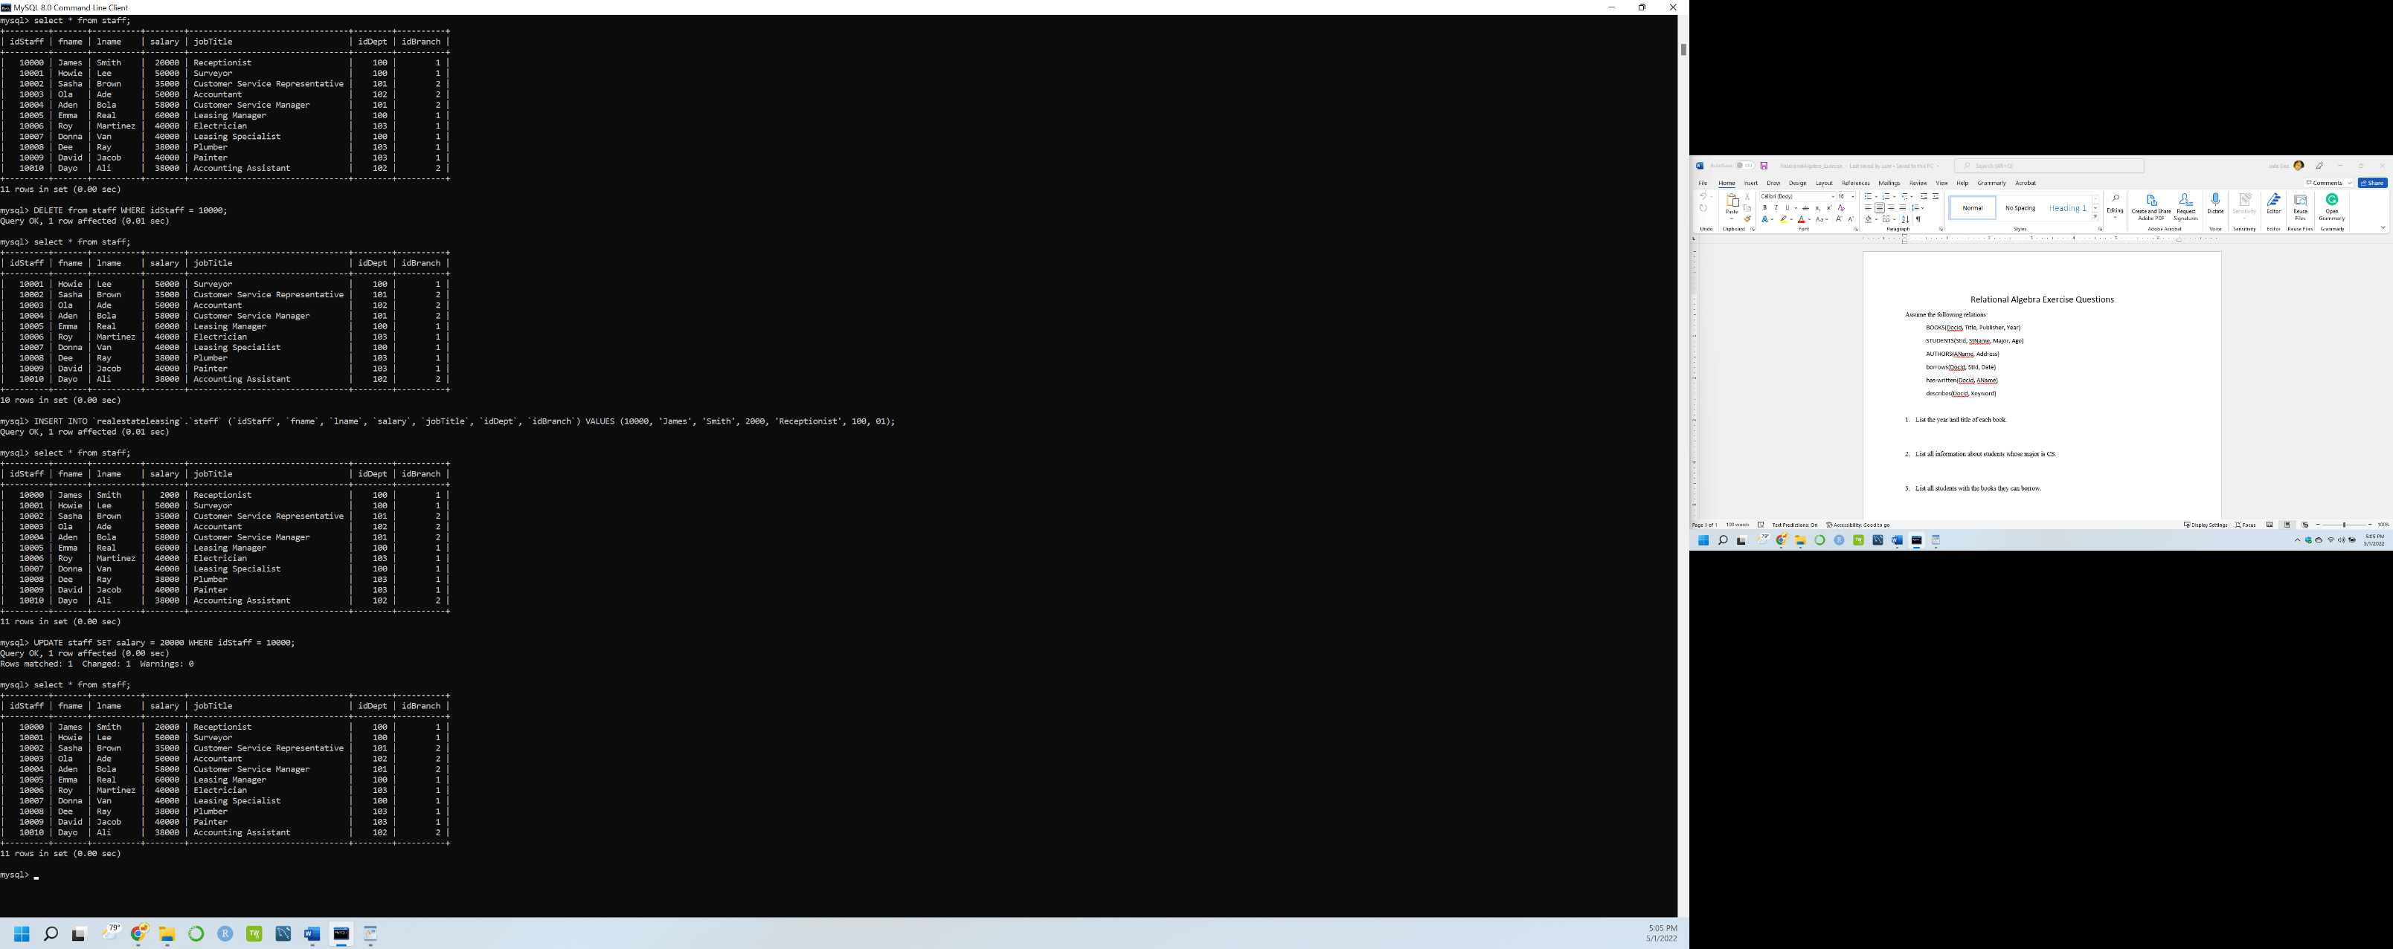

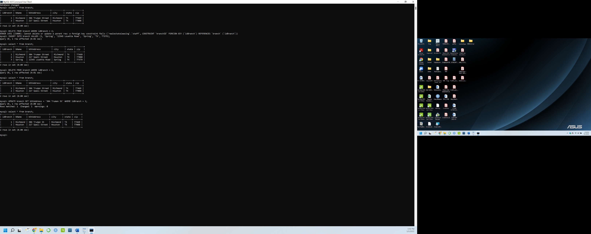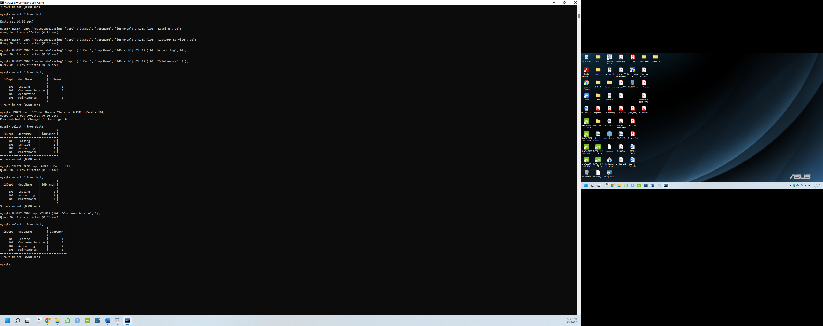

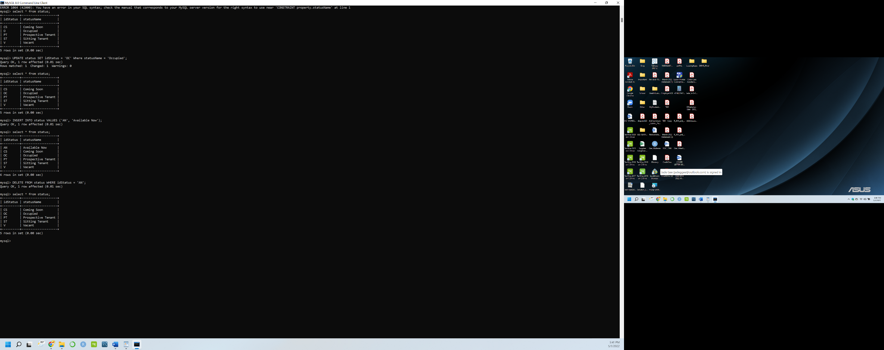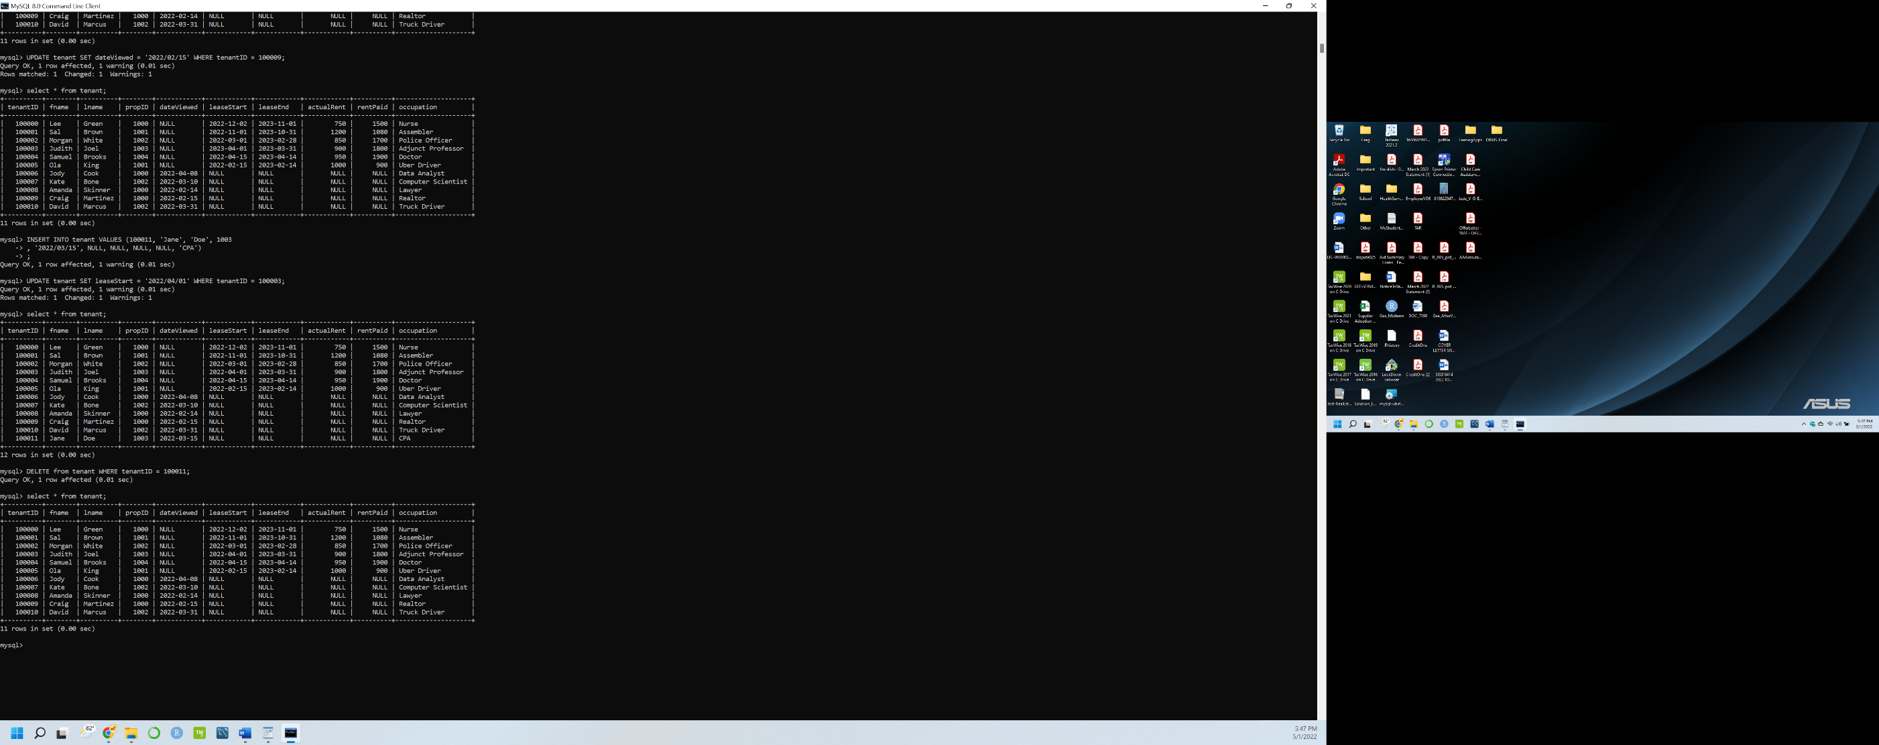

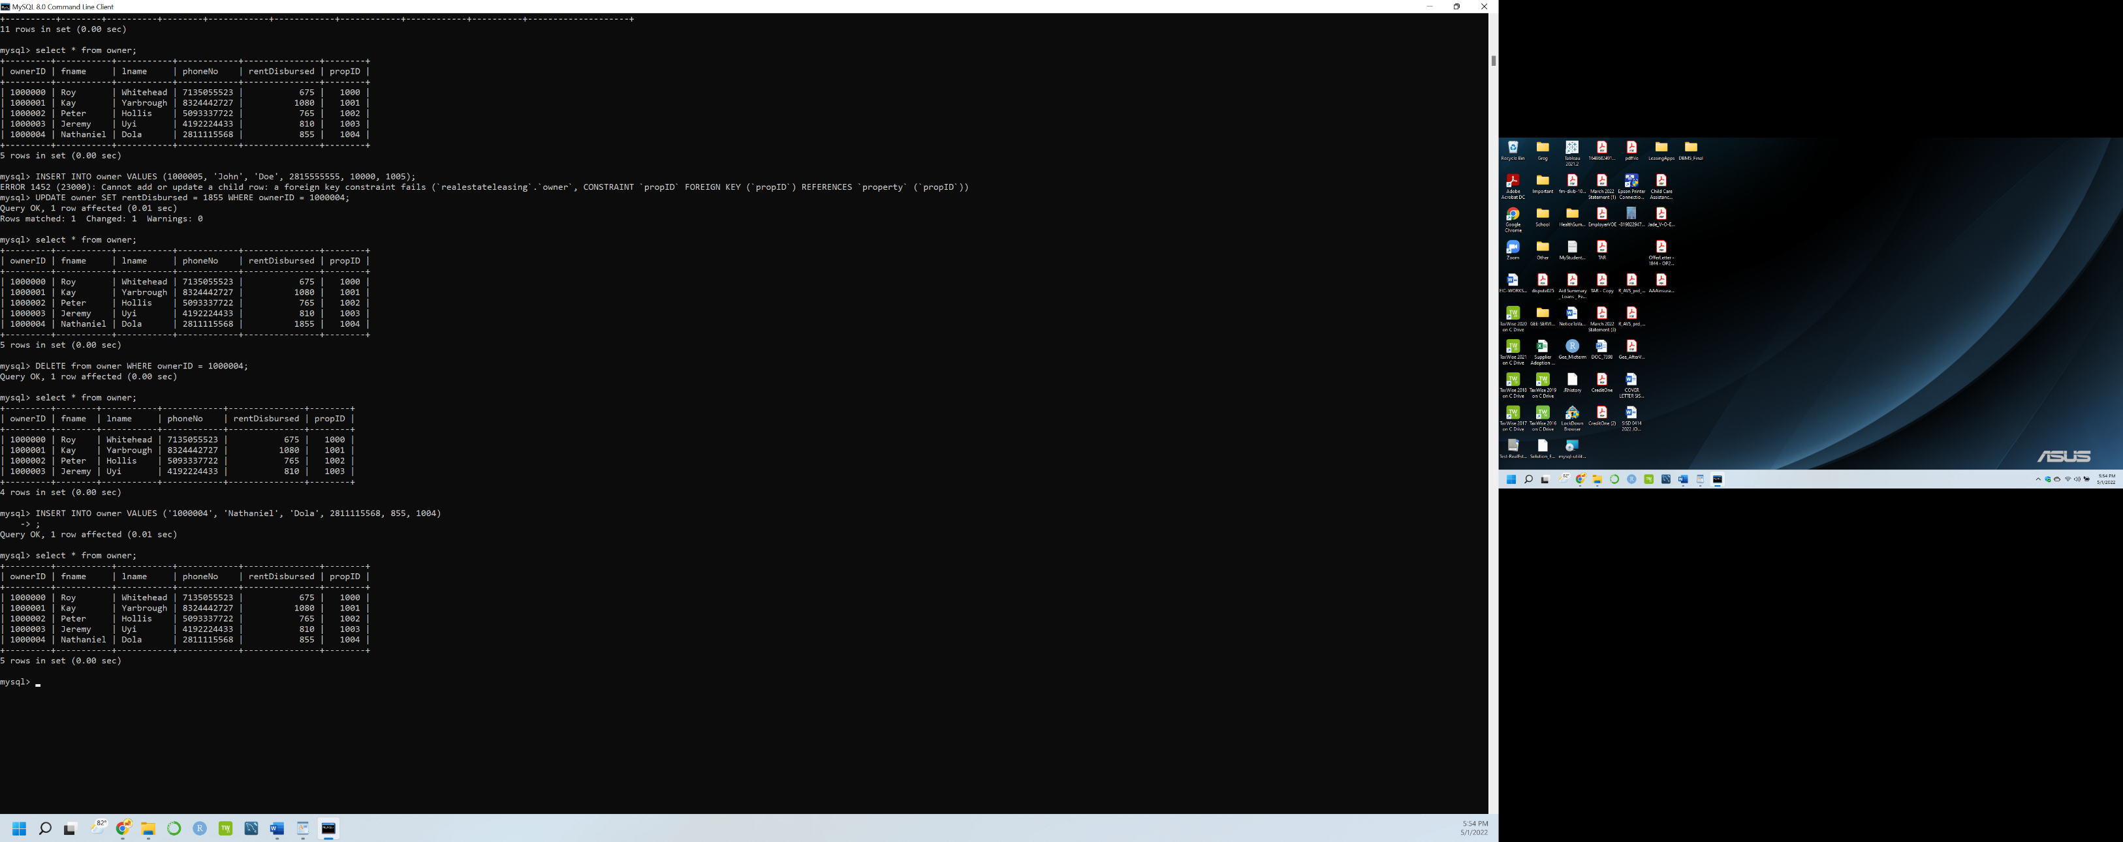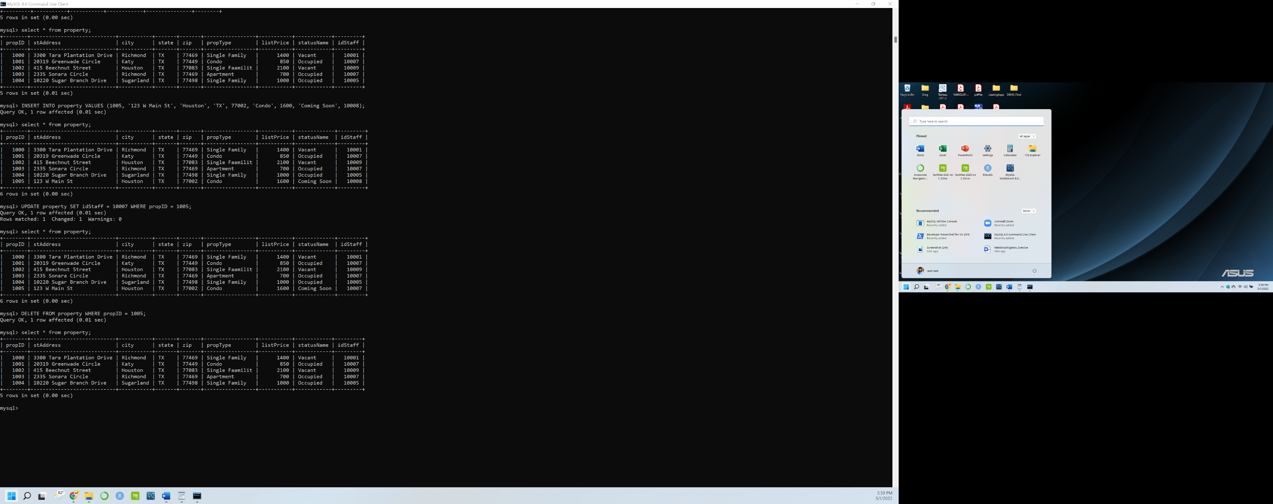

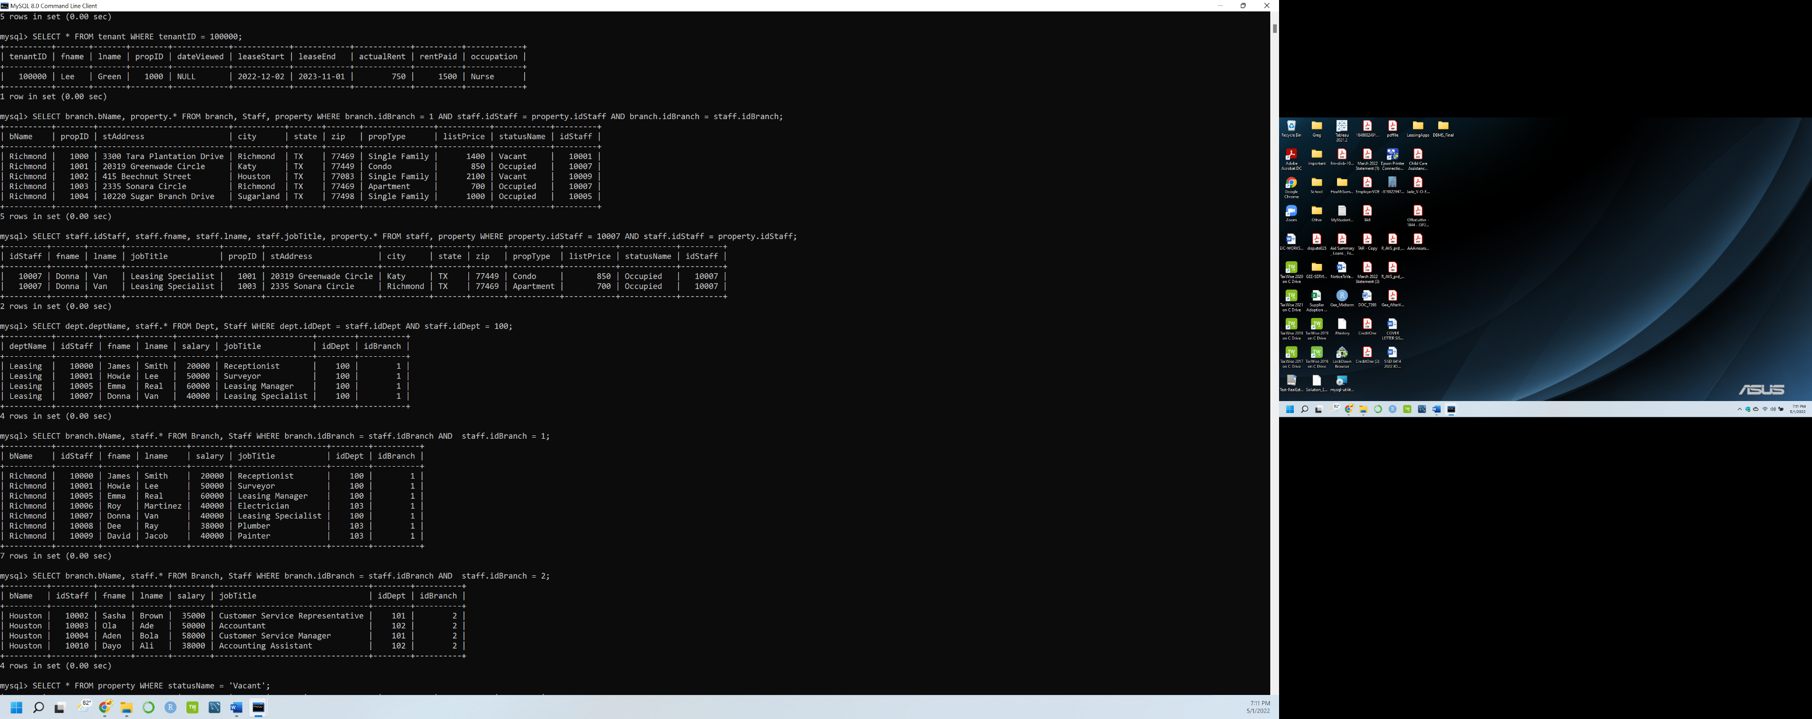

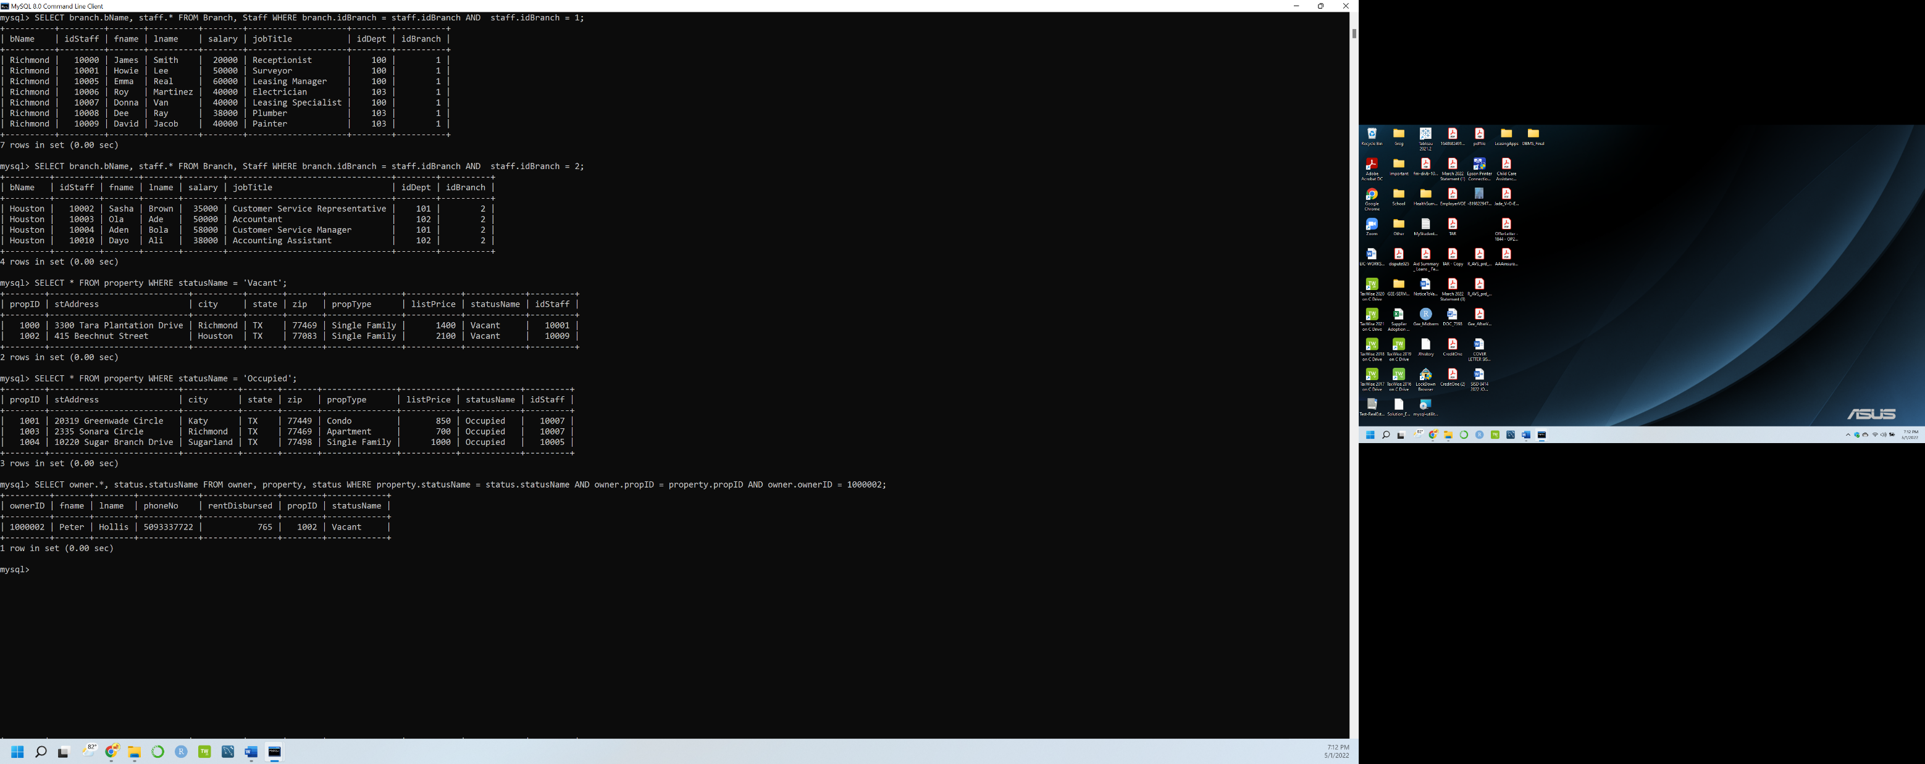

## Conclusion

By utilizing this database model, real estate leasing firms can manage transactions and be monumentally more successful. This database model will assist the real estate leasing firm in managing the listed properties and their owners. It will no doubt help improve future interactions and collection of data that would help further the success of the business. The database model also organizes and consolidates staff data to existing and new real estate firm branches to help view branch and department expenditures. By showing managers, directors, and owners' useful information they can interpret this data easily. This database is designed to store information relating to the operation of the business management of a real estate firm. It stores information about the Real Estate leasing firm staff members, their tenants, their property as well as owners. The database supports the operation of Real Estate firm records on rent paid by the tenants, rent remitted to the property owners. The database model will increase the efficiency of the real estate firms and further assist in keeping records of previous transactions made.

## Members Contributions

|  |  |  |  |  |
| --- | --- | --- | --- | --- |
| **Alaba Olanipekun** |  | **Jade Gee** |  | **Rohit Kumar** |
| Report writing  Building of the ER Diagram  Develop use cases  Data generation  Building relational model  Input data into database  Perform query |  | Report writing  Building of the ER Diagram  Building relational model  Perform query  Develop use cases  Build Database  Input data into database |  | Building relational model  Polished report writing  Building of the ER Diagram |

## Reference

Connolly, T. M., and C. E. Begg. *Database Systems: a Practical Approach to Design, Implementation and Management*. Pearson Education, 2010.